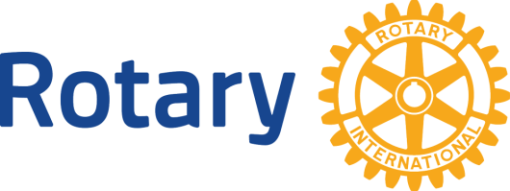 | Rotary International  District7820  Million Dollar Dinner

A dinner worth one million dollars to support all programs of our Rotary Foundation
October 9, 2014 – Pier 21 - Halifax
Yes, I want to be a guest with this gift.
Please give this pledge to your district representative on the Million Dollar Dinner planning committee (names at www.youareinvitedtodinner.com) or send to:
Carolyn Ferguson, Zone 24 Major Gifts Officer | Polio, Development & Partnerships
471 Orton Ave, Ancaster, ON, L9G 4M7
Tel 905.304.6831, Fax 866.854.8079, Carolyn.Ferguson@rotary.org
____________________________________________________________________________
My gift to the Rotary Foundation:
Name: ______________________________________________________________________
District: __________ Club:_______________________________________________________
Address: ____________________________________________________________________
Email + Phone ________________________________________________________________
I have given $___________ to the Rotary Foundation since July 1, 2012, or will give
$___________ by October, 2014. (Rotary partners may add their gifts together to qualify or top up existing contributions.) Totaling $10,000 USD.
I pledge to Join the Paul Harris Society and give $1,000 per year for the next ten years (Total gift of $10,000 USD).
I have made or will make a bequest to the Rotary Foundation in the amount of
$______________ and have completed or will complete the required paperwork by October 9, 2014 (Bequest recognition begins at $10,000 USD).
I have an existing benefactor or bequest gift commitment that I would like to increase to qualify for attendance at this event for a total of $______________

